**What were the consequences of the June 1967 War?**

**Lesson 9**

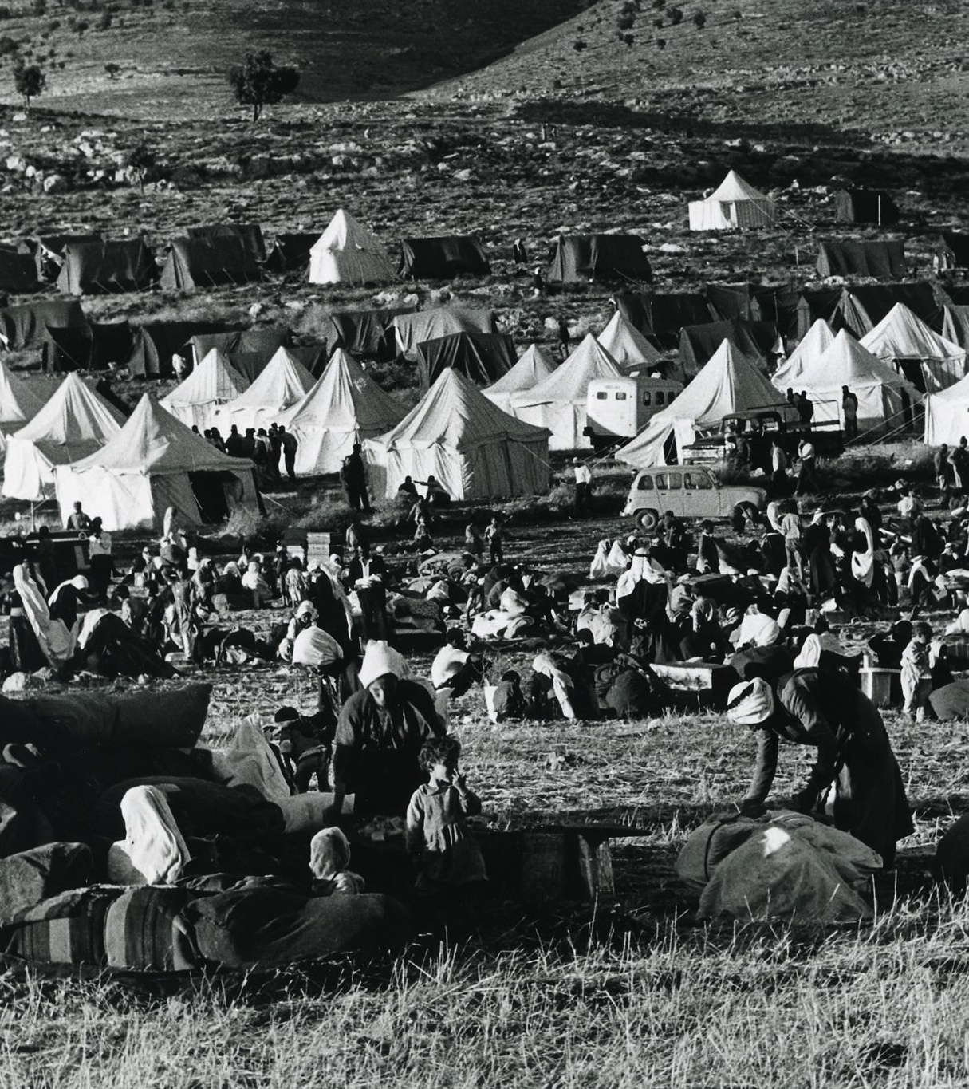

1967 refugee camp

**By the end of this lesson, you should be able to:**

Identify the increasing tension in the build up to the June 1967 War

Describe the events of 1967

Explain the consequences of 1967 for the Palestinians

**Keywords**

Occupation

Settlements

Golan Heights

Sinai Peninsula

Naksa

June 1967 War

1978 Camp David Accords

UN Resolution 242

**Knowledge check!**

1)What did the map of Palestine-Israel look like between 1948 and 1967?

2)Who controlled the following areas:

a) The new state of Israel

b) The West Bank

c) Gaza

3) Where did the Palestinians now live?

**Can you find these words?**

Occupation

Settlements

Golan Heights

Sinai Peninsula

Naksa

Have you come across any of these words before?

Can you define any of them?

**June 1967 War**

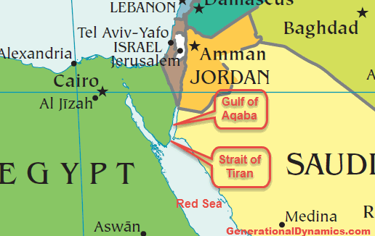

The June 1967 War is also known as the **Third** Arab-Israeli War, after the **First** Arab-Israeli War of 1948 and the **Second** Arab-Israeli War of 1956

**Tension** had been increasing between Israel and **Egypt** over access to the **Straits of Tiran,** the narrow sea passage which is strategically important to both Israel and Egypt. In 1967, for example, 90% of Israel’s oil came through the Straits of Tiran. Tension had also been increasing between Israel and **Syria** in the north

On 22nd May, Nasser closed the Straits of Tiran to Israeli shipping, and on 30th May 1967, a defence agreement was signed between Jordan and Egypt

On the morning of 5th June, **Israel attacked Egypt.** There was compulsory military service in Israel at this time, so Israel was ready to fight

**Map of the June 1967 War**

**The Six Days of the War**

-5th June / Day 1: Israel launches a surprise attack on Egyptian air forces and also attacks Syrian, Jordanian and Iraqi air forces. By midday, all of Egypt’s airfields and most of Egypt’s planes have been bombed. Israel also enters the **Sinai Peninsula**. Jordan’s airfields and air forces are also attacked, and Jordan responds by attacking Israeli cities including West Jerusalem

-6th June / Day 2: extensive fighting takes place between Israeli and Jordanian forces across the **West Bank**, particularly over control of Jerusalem

-7th June / Day 3: Israel captures East Jerusalem and the **Old City of Jerusalem** including the Western Wall and the Dome of the Rock

-8th June / Day 4: Israeli forces capture the **Sinai Peninsula**. They also capture the **West Bank**, with 300,000 refugees fleeing to Jordan

-9th June / Day 5: Israeli forces capture the **Golan Heights**, taking most of it from Syria

-10th June / Day 6: Israeli forces capture even more of the **Golan Heights**. Jordan, Egypt and Syria all accept the UN’s call for a ceasefire

**Activity**

Using this information, create a table of what happened in 1967 for the different parts of Palestine-Israel and the surrounding areas:

**The consequences of June 1967**

The death toll: around 800 Israelis were killed and 20,000 Arabs (including Palestinians)

As we have seen, 1967 was a huge **military victory** for Israel: by occupying the West Bank, Gaza, East Jerusalem, the Golan Heights and the Sinai Peninsula, the territory under Israel’s control had **quadrupled**

However, 300,000 more Palestinians had become refugees. This is why 1967 is also known as the ‘**Naksa’** meaning ‘setback’ in Arabic

Some of the Palestinian territory occupied by Israel in 1967 had religious significance, for example Jerusalem and Hebron. This encouraged thousands of Israelis to establish **settlements** in the West Bank and Gaza. The state of Israel invested in infrastructure for these settlers (eg. roads) and **life became increasingly difficult for the 1 million Palestinians who were now living under Israeli occupation**

**The map after 1967**

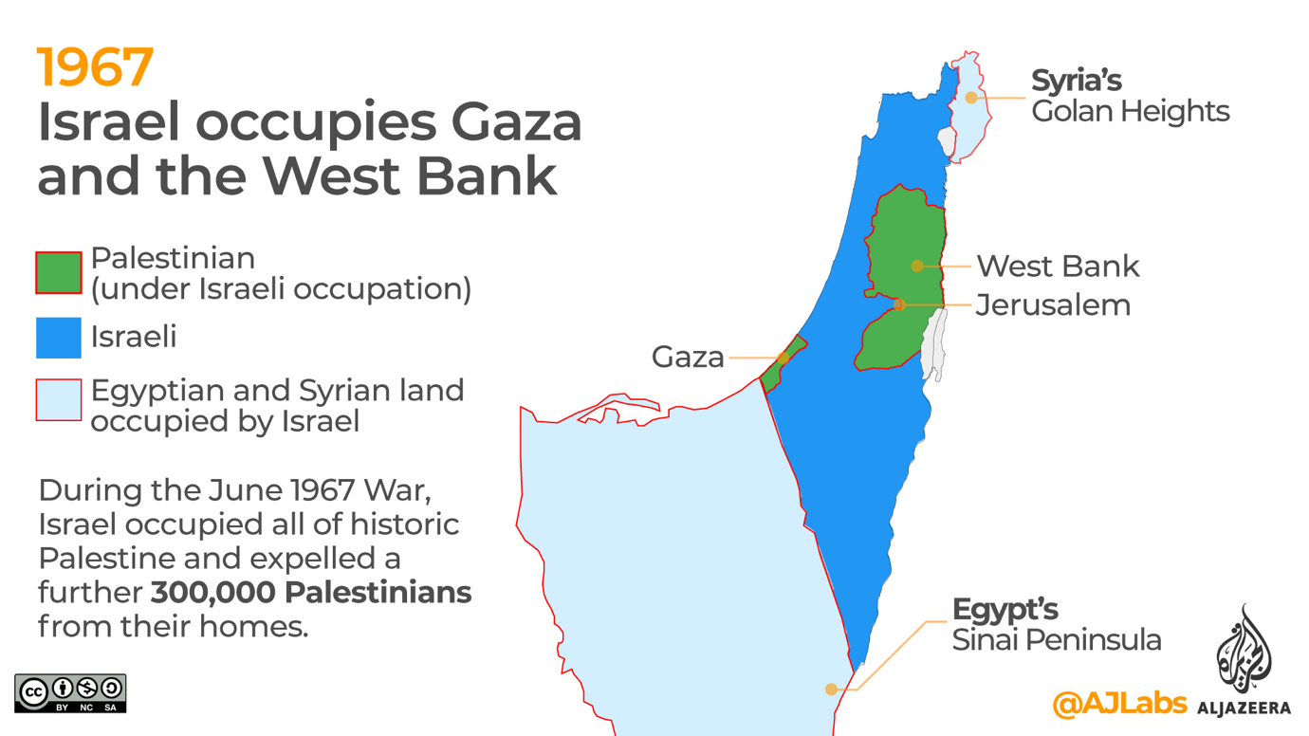

**Question**

What does this map tell us about the consequences of the 1967 war?

Are any parts of Palestine-Israel *not* under Israeli occupation here?

**Activity**

Imagine you were born in Palestine-Israel in 1900. Write a short description of how things have changed since you were born, finishing in 1967

**UN Resolution 242**

This wasadopted at the end of 1967, with the support of both the USA and the USSR. The main idea was **‘Land for Peace’:**

-Israel must withdraw from territory it had occupied during the June 1967 War

-The surrounding Arab countries such as Egypt and Jordan must recognise Israel’s right to exist

-The “refugee problem” should be settled fairly

What did Israelis and Palestinians think of this?

-Israelis were **divided**: they wanted peace, but they also wanted land! It protected them from surrounding Arab countries and it had religious significance too

-Palestinians were **not happy**: how much land would be returned? How was the refugee problem going to be settled *fairly*?

Eventually Resolution 242 was accepted by the countries mentioned above, despite its lack of clarity. This lack of clarity was going to cause **problems**…

**Question**

What was Resolution 242 and why was it problematic?

**The Yom Kippur War of 1973**

After 1967, the tension continued between Israel and Egypt, particularly over the Suez Canal. This was also becoming an arena for Cold War tension. The USSR was supporting Egypt and the USA was supporting Israel. In 1970, Gamal Abdel Nasser died and was replaced by Anwar Sadat as President of Egypt. On **Yom Kippur** (the holiest day of the year in Judaism), which was 6th October **1973**, **Egypt and Syria attacked Israel**. Israel was not prepared for this attack, and at first Egypt and Syria had the upper hand in reclaiming the Israeli-occupied Golan Heights in the north and the Sinai Peninsula in the south. But Israel soon mobilised its troops, managed to reclaim control of the land it had occupied in 1967, and kept pushing further. Pressure from the USA convinced Israel to agree to a **ceasefire** on 25th October

**The Camp David Accords, 1978:** two agreements between **Israel and Egypt** about **Israel and Palestine**. We’ll return to this in a future lesson

**Check your knowledge**

1) Why was there increasing tension in the build up to the June 1967 War?

2) What happened in 1967?

**Exam-style question:**

Explain **two** consequences of the June 1967 War [8 marks]